SUMMERVILLE STABLES
2024 SUMMER KIDS HORSE CAMPS

Session #1: June 17-21 Session #2: June 24-28 Session #3: July 15-19 Session #4: August 5-9 Session #5: August 12-16
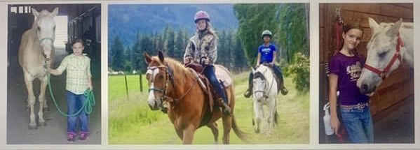

Cost for 5 Day Camp: 9:00-5:00 ~ $595 / 9:00-3:00 ~ $545
Cost for 5 Day ½ Day Camp: 9:00-12:00 ~ $295 / 2:00-5:00 ~ $295
Cost for Single Day: 9:00-5:00 ~ $145 / 9:00-3:00 ~ $125 / 9:00-12:00 ~ $75 / 2:00-5:00 ~ $75

Summerville Stables is inviting all horse loving kids ages 6 & up to join us this Summer for our weeklong horseback riding camp! We will enjoy daily morning and afternoon riding sessions with instruction in western and english riding, indoor and outdoor arena riding, groundwork, obstacles, mounted games, driving, jumping, cattle sorting, and relaxing trail or ideas through the woods! Learn horse care and have fun with horse crafts, games, go carts, and much, much more!!! Bring your own kid safe horse or ride one of our gentle, safe, experienced lesson horses or ponies! No experience necessary, beginners welcome, something for all skill levels! Bring a sack lunch M-Th, barbecue lunch provided Friday. Bring a swimsuit, towel, boots, and a smile!

Space is limited to 12 riders per session. Pre-registration is required. A 50% non-refundable deposit is required to hold your child’s spot. Payment in full is due no later than the first day of camp. A signed liability release must be on file for each rider.

We accept Cash, Checks, Credit Cards, and Venmo!
Call or Text 541-910-8383, email reedtracy145@gmail.com, or visit www.summervillestables.com for more information. Completed forms and deposits can be dropped off or mailed to 66967 Hunter Rd, Summerville, OR 97876 or forms can be texted or emailed and deposit sent through Venmo at Tracy-Reed-80 with Session # listed.

——————————————————————————————————————————

Rider’s Name(s):___________________________________________________ Age(s):______________________
Address:_________________________________________________________ Phone #:_____________________
Parents Name(s):)_____________________________________________ Session #:_________ Amount: ________
Email:_________________________________________________ Riding Experience:_____________________

T-Shirt Size (Circle One): Yth Small / Yth Med / Yth Large / Yth XL / Ad Small / Ad Med / Ad Large

